**AI LAB 6.4**

Task1:write a python program class named with attributes name,roll_number and marks complete methods for displaying details and checking if marks are above average.

**Code:**

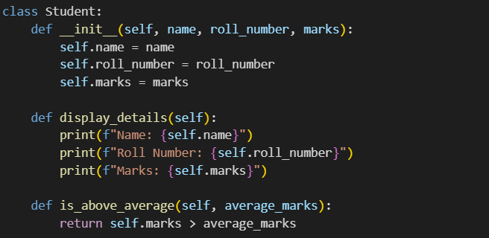

**Output:**

Task 2:write the first two lines of a for loop to iterate through a list of numbers how to calculate and print the square of even numbers only.

**Code:**

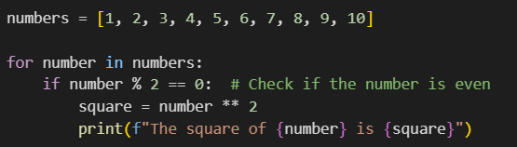

**Output:**

Task3:write a python program to create a class called bank account with attributes account_holder and balance to complete methods for deposit(),withdraw(),and check for insufficient balance.

**Code:**

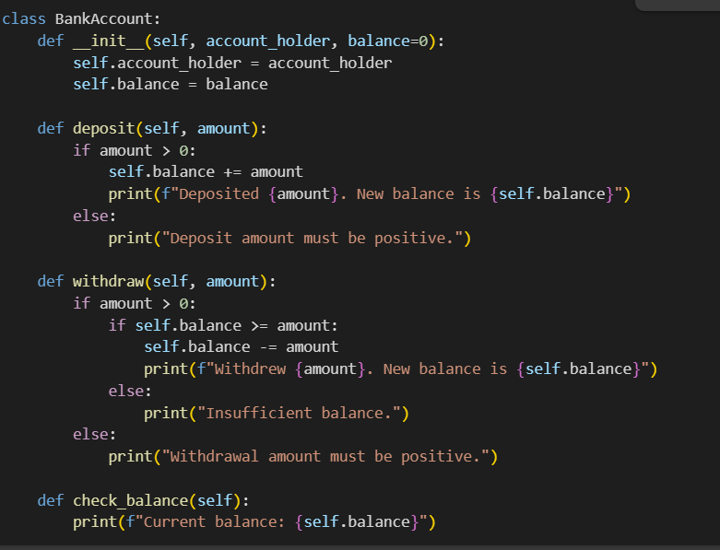

**Output:**

Task4:write a python program to define a list of student dictionaries with keys name and score.write a while loop to print the names of students who scored more than 75.

**Code:**

**Output:**

Task5:write a python program to begin writing a class shoppingcart with an empty items list to generate methods to add_item,remove_item,and use a loop to calculate the total bill using conditional discounts.

**Code:**

**Output:**

